INFORMATION CONSENT FORM
Intense Pulsed Light (IPL) treatment for dry eye

Dear Sir or Madam,
You will receive Intense Pulsed Light treatment for dry eye related to Meibomian Gland Dysfunction and/or lacrimal gland, or an inflammatory lesion of the skin.

Dry eye context
Dry eye is a very common condition caused by multiple factors. In most cases, it is related to Meibomian Gland Dysfunction that affects the eyelids and/or to lacrimal gland dysfunction.

What are the current solutions for dry eye treatment?
- Heating and manual massage of eyelids
- Eyelid hygiene
- Tear substitutes (tears, gel)
- Scleral lenses in the event of treatment failure and severe dryness
- Intense Pulsed Light (IPL) therapy

What are the mechanisms of action of Intense Pulsed Light (IPL) therapy?
The IPL therapy is administered using a device that generates Intense Pulsed Light (flash). IPL system has been designed to suit the majority of skin types.
The light transmitted on the skin has several actions:
- It stimulates the parasympathetic nerve and accelerates the metabolism of the Meibomian Glands and lacrimal glands.
- It reduces skin (i.e. rosacea) and eyelids (i.e. blepharitis) inflammation.
- It decreases Demodex

What is the treatment procedure?
Intense Pulsed Light is a therapeutic option offered by your ophthalmologist to potentially complement other treatment solutions.
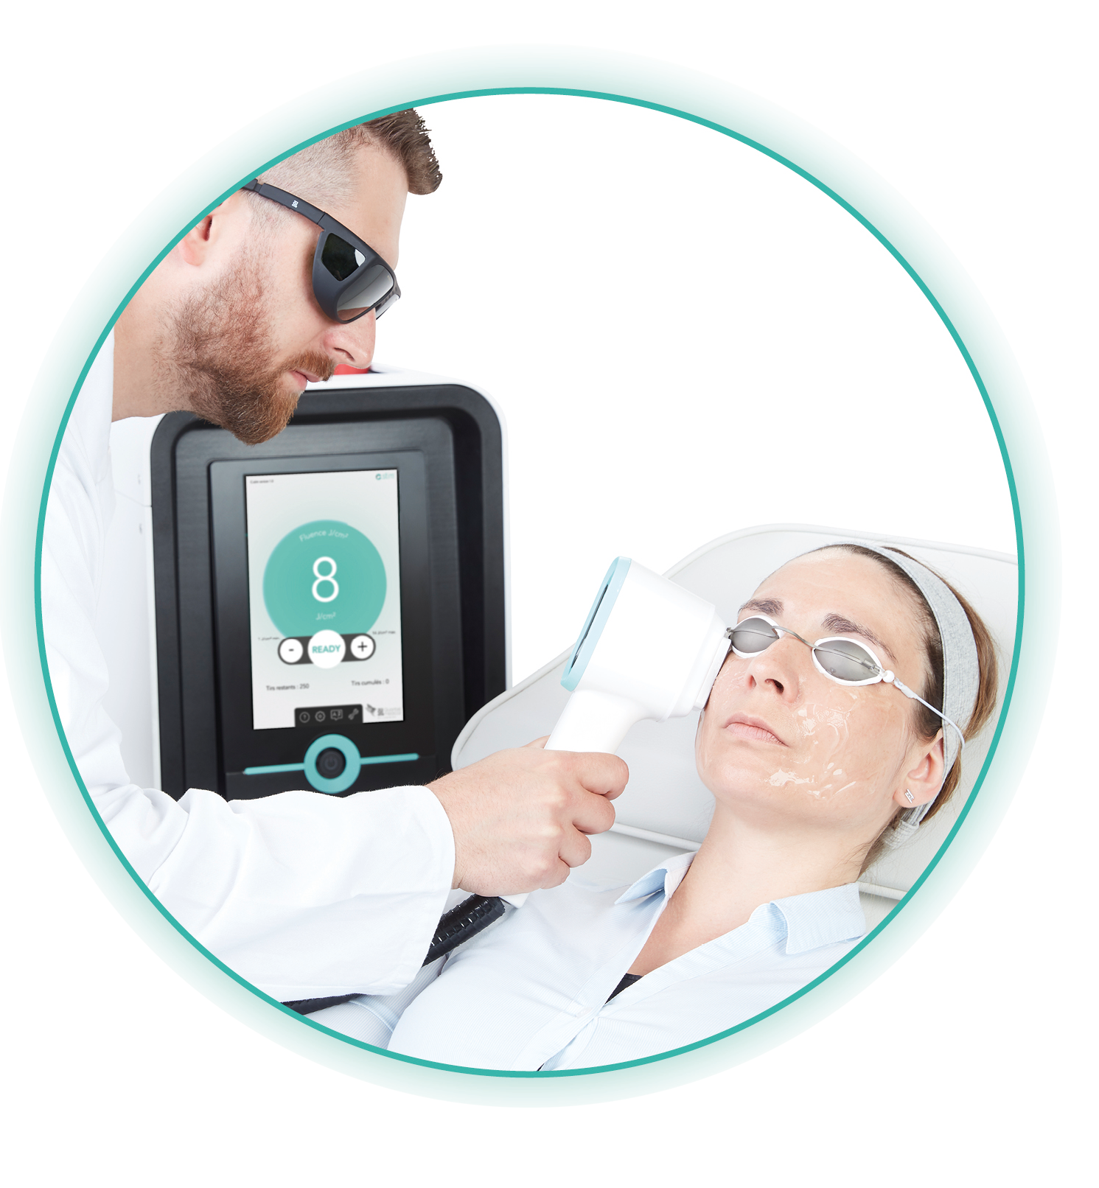
- Quick and simple treatment
- 4 shots to the cheek
- 3 sessions
- Safe and painless treatment

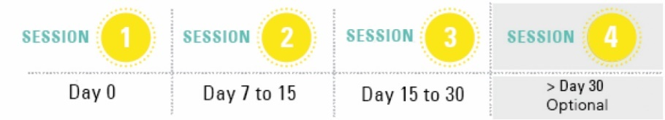

What are the results of clinical studies?
The results of clinical studies on IPL technology have reported:
- Enhancement of the tear film quality
- Improvement of many symptoms: sensation of dryness, foreign body sensation in the eye, itchiness, sensation of burning, eyestrain, blurred vision, sensitivity to light, watery eyes, pain.

What are the contraindications?
The IPL system cannot be used if you answer positively to one of the following questions. Your doctor must be informed of all your ongoing medical treatments and/or any newly started treatment(s) during the Intense Pulsed Light therapy, as well as any changes to your health during this treatment protocol.
 | Session 1 |  | Session 2 |  | Session 3 |  | Session 4  (Optional)
Date | …./…../…. |  | …./…../…. |  | …./…../…. |  | …./…../….
 | YES | NO | YES | NO | YES | NO | YES | NO
Injured, burnt or infected skin
Precaution for pregnant and breastfeeding patient
Exposure to artificial UV radiation, or use of a self-tan product within the last two weeks
Consultation with a dermatologist is necessary in case of medical history of the face: cancer, vitiligo, psoriasis, lupus erythematosus, keloids …
Photo-sensitising treatment in progress
History of sun hypersensitivity

Adult patient agreement
Doctor ……………………………………………………… has suggested that I receive Intense Pulsed Light therapy for dry eye. He explained to me the benefits and risks of intense pulsed light treatment. I, the undersigned Ms/Mr, ……………………………………………………………………… give my agreement to start intense pulsed light therapy and for the collection of my personal data above.
Agreement of the legal representative of the minor patient
Doctor ……………………………………………………… has suggested an Intense Pulsed Light therapy for dry eye to ………………………………………………………, minor patient of which I am the legal representative. He explained to me the benefits and risks of intense pulsed light treatment. I, the undersigned Ms/Mr, ……………………………………………………………………… give my agreement to start intense pulsed light therapy and for the collection of the personal data above of the minor patient.
XS_IPL_CP2/CONS_AN_220103

At ……………………………………………………………
On …………………………………………………………
SIGNATURE

